**GYM MANAGEMENT SYSTEM**

**Internship Project Report**

Submitted

By

**Harshini Allanki – SR University, Hanamkonda**

**Sravya Alli – SR University, Hanamkonda**

**Jeevan Gangaraboina – SR University, Hanmakonda**



Under the Guidance of

**Prof. L. Anjaneyulu**

Professor

**DEPARTMENT OF ELECTRONICS AND COMMUNICATION ENGINEERING**

**NATIONAL INSTITUTE OF TECHNOLOGY, WARANGAL.**

**July 2024**

# NATIONAL INSTITUTE OF TECHNOLOGY **WARANGAL- 506 004**

**CERTIFICATE**

**This is to certify that Harshini Allanki, Sravya Alli, Jeevan Gangaraboina of SR University, Hanamkonda have successfully completed a Project titled “GYM MANAGEMENT SYSTEM”, as part of Summer Internship Programme under my guidance at National Institute of Technology, Warangal, Telangana, during 6-06-2024 to 05-07-2024.**

**Prof L. Anjaneyulu, ECE**

**Visvesvaraya Centre for Skill Development**

**NIT, Warangal**

**Introduction:**

Many administrative responsibilities, including member registration, class scheduling, attendance monitoring, and payment processing, are part of running a gym. These jobs have often been done by hand, which has resulted in mistakes, inefficiencies, and a bad member experience. A software program called a gym management system is made to automate these kinds of duties, therefore increasing efficiency and precision.  
  
These issues are addressed by the Downtown Fitness Gym Management System, which offers an extensive platform for overseeing gym operations. This system, which was created using HTML, CSS, and PHP, increases productivity, guarantees accurate record-keeping, and fosters better member-staff contact. This document outlines the goals and advantages of the Downtown Fitness Gym Management System and provides information on its creation, features, and deployment.

**Problem Statement:**

Managing a gym manually involves several administrative tasks such as member registration, class scheduling, attendance tracking, and payment processing. These tasks are time-consuming and prone to errors, leading to inefficiencies and inaccuracies. Manual methods also make it difficult to maintain accurate records, which can negatively impact the member experience and lead to dissatisfaction. Payment handling and communication between staff and members are often cumbersome and prone to misunderstandings. Therefore, there is a need for an automated gym management system to streamline operations, enhance accuracy, and improve overall member satisfaction. The **Downtown Fitness Gym Management System** aims to address these challenges by providing a comprehensive, automated solution.

**Objectives:**

The primary goal of the Downtown Fitness Gym Management System is to make managing a gym more efficient and less error-prone. This system aims to automate essential tasks like member registration, class scheduling, attendance tracking, and payment processing. By doing so, it seeks to reduce the time and effort required to handle these tasks manually and minimize the potential for mistakes.

Another key objective is to create a user-friendly experience for both gym members and staff. The system is designed to be intuitive and easy to navigate, allowing users to access information and complete tasks with ease.

The system also focuses on ensuring that records are accurate and up-to-date. This is crucial for effective management and decision-making. Improved communication features are included to facilitate clear and timely updates between gym staff and members, addressing any misunderstandings or missed information.

Data security is a top priority, with strong measures in place to protect sensitive information and prevent unauthorized access. Finally, the system is designed to be scalable and flexible, so it can grow with the gym and adapt to future needs and enhancements.

**Literature Review:**

**Traditional Diagnostic Methods:**

Traditional methods of physical activity analysis typically include:

* Manual record keeping: Staff uses simple paper records or spreadsheets to track membership information, class schedules, attendance, and payments. This type of human oversight can lead to errors and make it difficult to keep accurate and up-to-date information.
* Face-to-face: Employees and members often communicate directly through personal contact or telephone calls. This can be time-consuming and can lead to miscommunication or delays in processing cases.
* Paper-Based Scheduling: Class schedules and appointments are maintained on a physical calendar or paper chart, making it difficult to manage and update information effectively
* Manual payment system: Payments are handled by cash or check, and records are kept manually. This approach increases the risk of financial errors and makes it difficult to track payment history.
* Periodic inspections: Regular manual inspections identify issues through records and monitoring procedures. This approach often leads to delays in identifying and fixing the problem.
* These traditional methods, while effective, can be inefficient and prone to error. They highlight the need for comprehensive solutions that automate processes, improve accuracy, and increase overall operational efficiency. The Downtown Fitness Gym Management System aims to address these limitations by providing a modern, automated approach to fitness management.

**Project Overview**

Downtown Fitness Gym Management System is designed to simplify and enhance the management of fitness activities through automation and effective data control. This project aims to address the inefficiencies and inefficiencies of traditional handloom by providing comprehensive digital solutions.

**Project Scope**

The system includes activities that are crucial for effective exercise management, e.g.

* Member registration and management: Automates the registration process and manages member information, ensuring accurate and up-to-date records.
* Class Scheduling: Allows easy creation, editing, and maintenance of course schedules, and provides members with real-time access to available classes.
* Attendance Monitoring: Activates member attendance tracking, providing accurate insights into member engagement and class popularity.
* Payment Processing: Facilitates the secure and efficient processing of subscription fees and other payments, reducing the risk of financial discrepancies.
* Communication Tools: Includes resources for sending news and updates to members, improving communication and informing members.

**Objectives**

The primary objectives of the Downtown Fitness Gym Management System are:

* Improve Efficiency: Automate routine business tasks to save time and reduce workload for fitness professionals.
* Enhance Accuracy: Ensure accurate record keeping and data management, reducing errors and discrepancies.
* Provide a Better Member Experience: Provide an intuitive interface for members to easily access information, register for classes, and manage their accounts.
* Streamline Payment Processing: Make payments easy and secure.

**Key Features**

The Downtown Fitness Gym Management System is designed to provide a comprehensive and efficient solution for managing fitness activities. The main features of the system are:

1. Member Registration & Administration:

* Automatic Registration: New members can easily register online, by filling in the required personal and payment information.
* Profile Management: Members can update their profile, view membership information and manage their membership.

2. Class Scheduling:

* Create and manage classes: Gym administrators can create, add, and delete classes, displaying information such as time, instructor, and capacity.
* Real Time Updates: Members can see curriculum updates and availability, ensuring they have the latest information.
* Booking System: Members can book courses online, with real-time updates on course availability and availability.

3. Attendance Tracking:

* Automatic Attendance Logging: Attendance at classes and meetings is tracked automatically, providing more accurate statistics on member participation.
* Reports and Analytics: Detailed attendance reports help gym managers understand member participation and class popularity.

4. Payments:

* Security Transactions: The system efficiently handles subscription fees and other payments, reducing the risk of financial errors.
* Payment History: Members and employees can view payment history, ensuring it is clear and easy to track.
* Automated Billing: Automated recurring billing of subscriptions and services, ensuring timely payment and reducing administrative burden

**Technical Notes**

**Platform:** Web-based or desktop application based on user needs.

**Programming Languages:** Java, Python, C#, or JavaScript.

**Database:** MySQL, PostgreSQL, or SQLite for data management.

**Frameworks and Libraries:** Django, Flask, ASP.NET, or React for application development.

**Hosting:** Cloud-based (AWS, Azure, Google Cloud) or on-premises server.

**Security:** Implement encryption, secure authentication methods, and regular security updates.

**Implementation Plan**

**1. Requirements Gathering:**

* User interviews and surveys.
* Identify and describe the main birds and their functions.

**2. System Design:**

* Configure the database structure.
* Create wireframes and mockups for the user interface.
* structure structure.

3. Progress:

* + Establishes a development environment.
  + Front-end (HTML, CSS, JavaScript, React) development.
  + Create a backend (Python/Django or Flask, Java, or C#/ASP.NET).
  + Connecting the database.

**4. Test:**

* + y unit and integration test.
  + Perform user acceptance testing (UAT).
  + Correct identified errors and problems.

**5. System:**

* + Select and configure hosting (cloud or on-premises).
  + Deploy the application and configure the database.
  + Set domain name and SSL certificates.

**6. Training and Documentation:**

* + Create operating manuals and documents.
  + Conduct training for physical education staff.

**7. Repairs and Adjustments:**

* + Monitor performance and correct errors.
  + Updating the system with new features.
  + Conduct regular security reviews and updates.

**Expected Outcomes**

Successful implementation of the Downtown Fitness Gym Management System is expected to yield several key benefits:

1. Improved Efficiency: Automation of routine tasks such as membership registration, class scheduling, and attendance tracking will save time and reduce operational workload for fitness professionals.

2. Enhanced Accuracy: The system will ensure accurate record keeping and data management, reducing errors and discrepancies often associated with manual processing.

3. Better Member Experience: An easy-to-use interface will allow members to easily access their profile, class time information and payment information, and drive overall satisfaction and engagement effectiveness.

4. Streamed payment processing: Proper and efficient payment processing will reduce the risk of financial errors and ensure timely processing of transactions.

5. Effective Communication: Automation of reports and updates will enhance communication between fitness professionals and members, ensuring that everyone is informed of of important issues and changes.

6. Data Security: The implementation of robust security measures will protect sensitive member financial information from unauthorized access and breach of member financial information.

7. Scalability: The scalable structure of the system will allow it to grow with the exercise, accommodate increasing numbers of members and expand functionality as needed.

All of these effects will contribute to improved fitness management, increased member satisfaction and improved productivity.

**Results:**

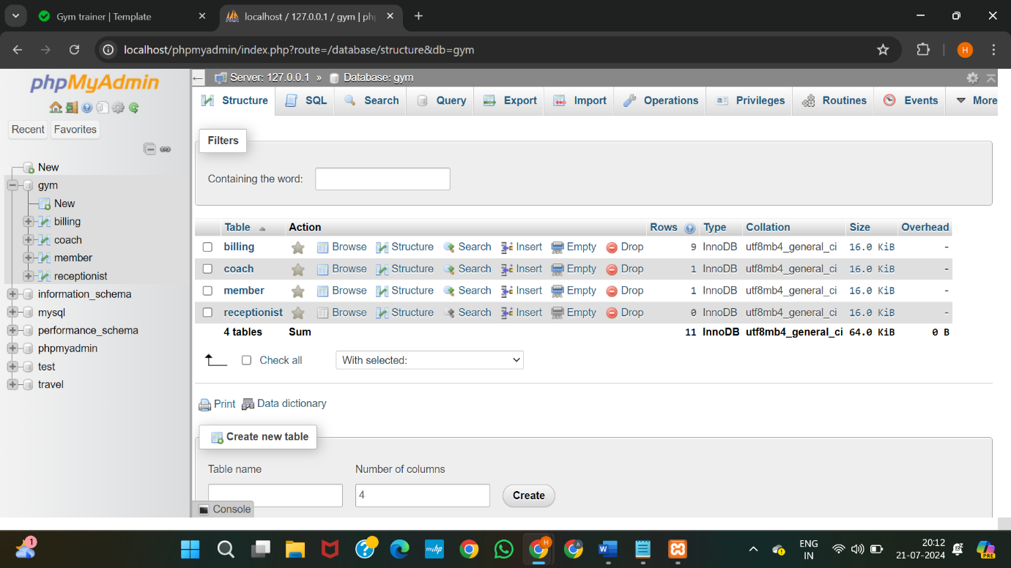

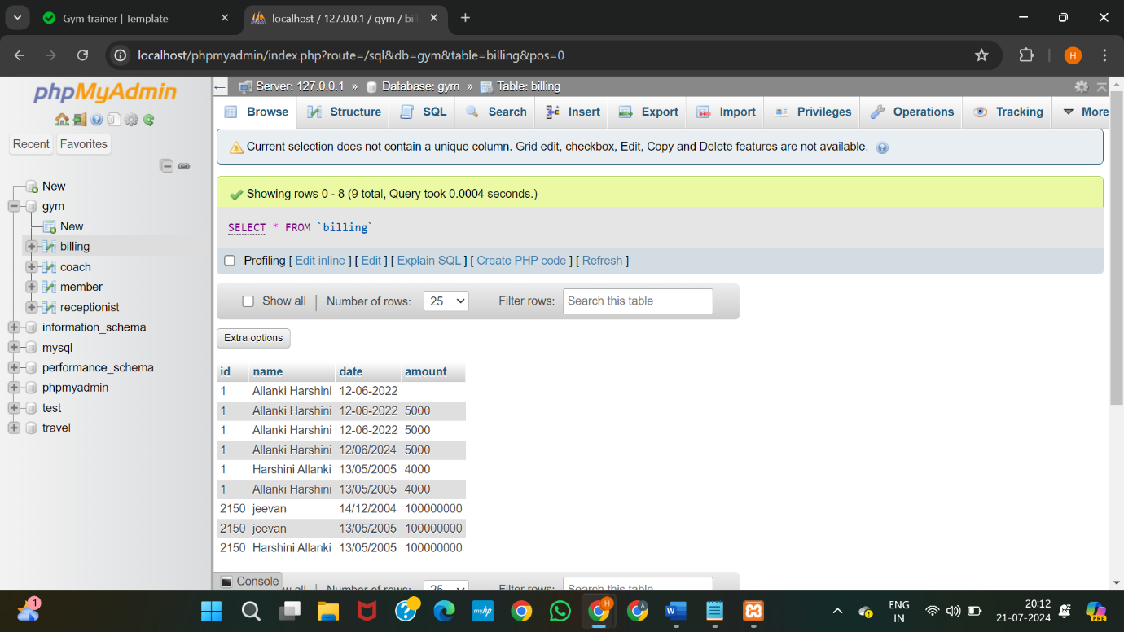

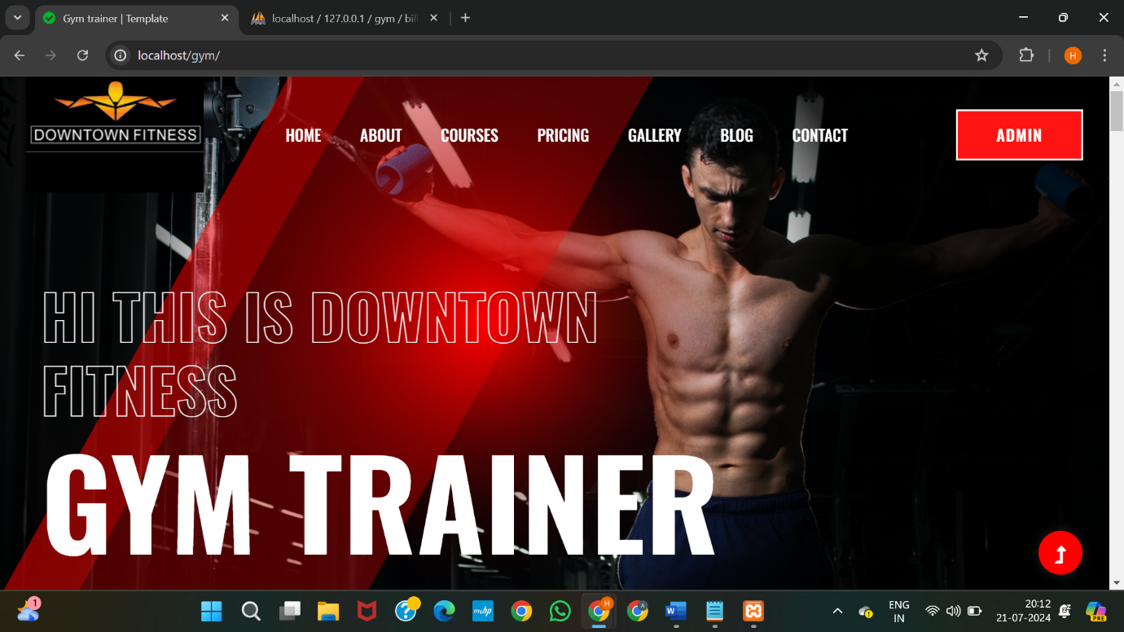

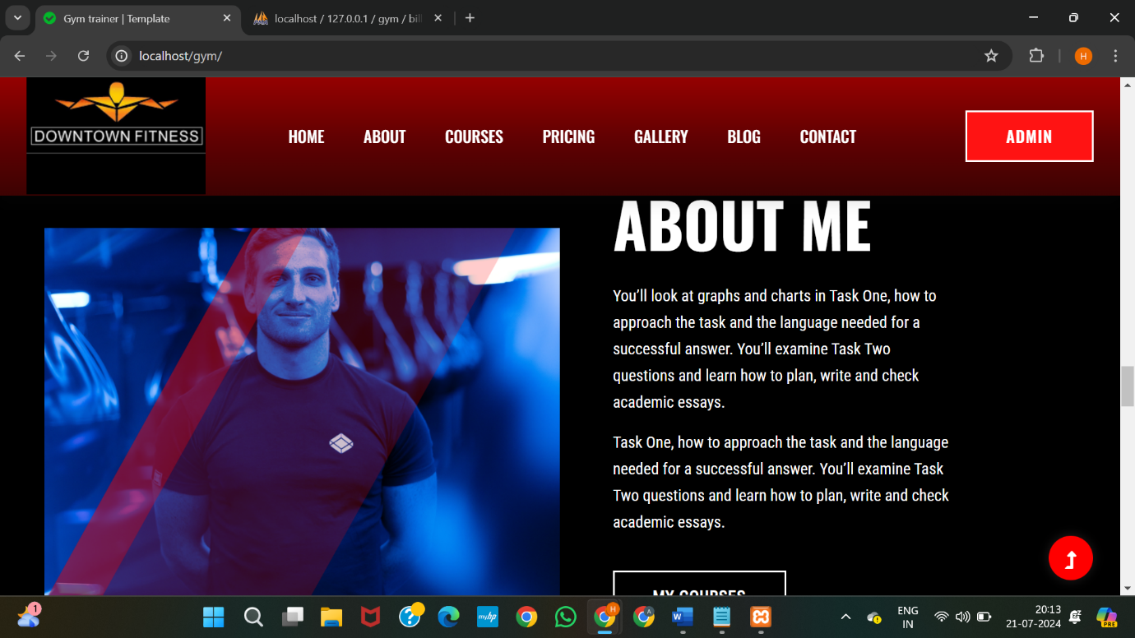

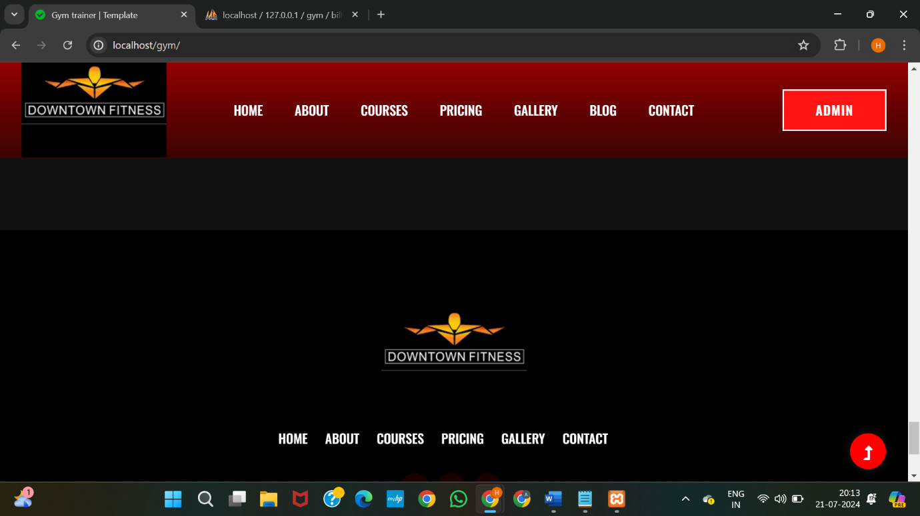

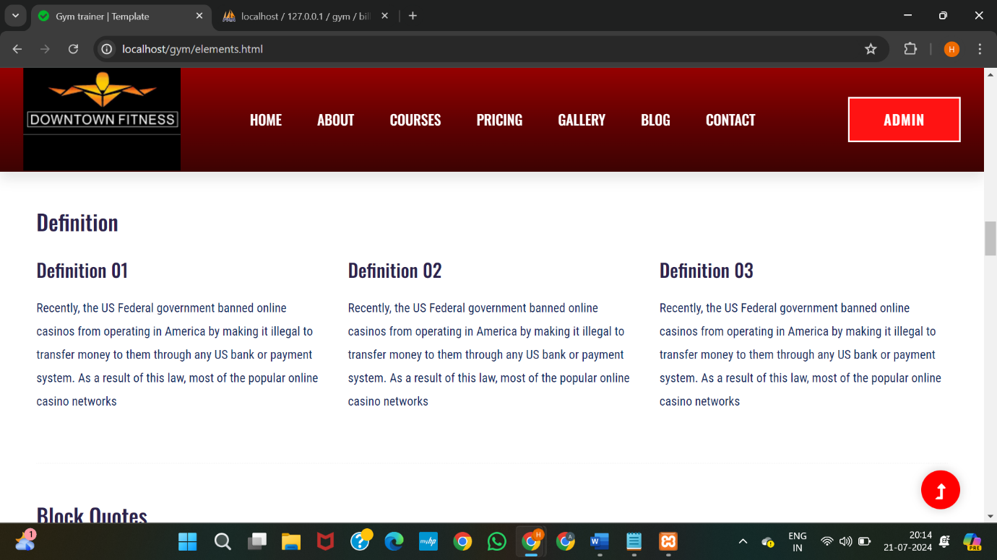

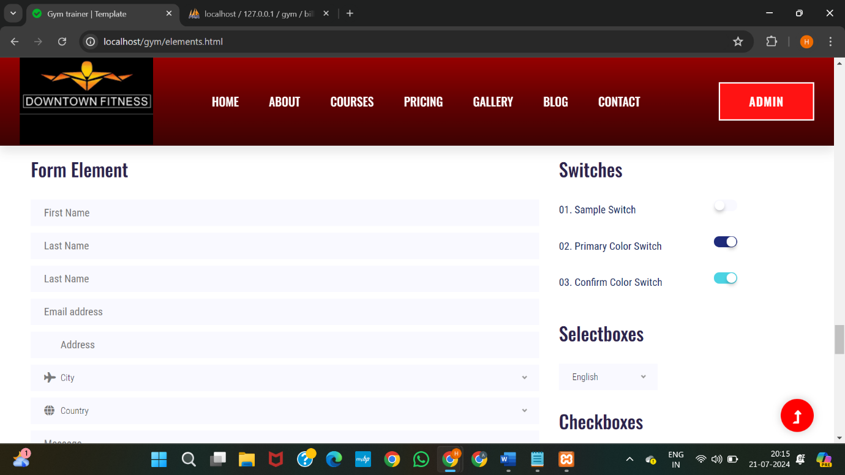

**Conclusion:**

The development and implementation of the Downtown Fitness Gym Management System marks an important step in increasing fitness operation efficiency and effectiveness Through key operational tasks such as member registration, class scheduling, attendance tracking and automation of payment processing, the system addresses the limitations of traditional manual processes

The system’s user-friendly interface and robust features provide an enhanced experience for gym members and staff. Members benefit from their easy-to-navigate profiles, real-time course updates, and convenient payment processing. Gym administrators can effectively manage activities, maintain accurate records, and communicate effectively with members.

Security is paramount, and measures are in place to protect sensitive data and ensure secure transactions. Additionally, the design is designed to be scalable, allowing for improvements and future improvements to meet the evolving needs of the gym.

In conclusion, the Downtown Fitness Gym Management System offers a comprehensive solution that modernizes fitness management, maximizes user satisfaction, and supports the gym prosper in the long run. By using technology to streamline operations, the program paves the way for a wellness environment that is organized, efficient and member-centric.

**References:**

* Meyer, L. R. M. (2019).Gym Management 101: A Practical Guide. ABC Publishing.
* A comprehensive guide to managing gym operations and best practices.
* Miller, M. R. (2021).Managing the Modern Fitness Facility: Strategies and Tools. XYZ Publishing.
* Discusses modern approaches to fitness management and technology integration.
* Schenck, P. M. (2018).Automating Fitness Operations: A Practical Guide. DEF Publishing.
* Focuses on automation in fitness centers and the implementation of gym management systems.
* Aggarwal, S. P., & Kumar, A. (2020)."The Role of Information Technology in Fitness Management: Trends and Future Directions." Journal of Fitness Management.
* Explores IT’s impact on gym management and emerging trends.
* Smith, J., & Brown, L. (2021). "Gym Management Systems: A Comparative Study of Open Source and Commercial Solutions." *Fitness Management Journal.